2021 PASFAA Conference Virtual Survival Guide

- For the Best Conference Experience, download the WHOVA App for your phone or laptop.
- Get entered into the Passport contest by visiting the Business Partners at their Exhibitor Booths for a chance to win one of three Gift Cards!
- Remember to complete the surveys at the end of each session within

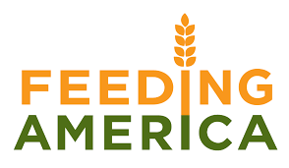
- Support our charity, Feeding America, by participating in the PASFAA 50/50 Drawing
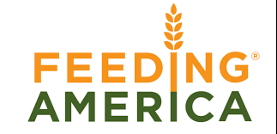

- is your portal for the PASFAA Conference. You will link to sessions, and exhibitors through Zoom links in Whova. View the Whova Guide for detailed information.
- First-Time Attendees be sure to attend the special session on Monday at 9:00am where you will meet executive council, some past PASFAA President’s, and learn more about our great organization.
- Don’t forget to update your volunteer form each year! PASFAA’s success depends on great volunteers, like you!!

