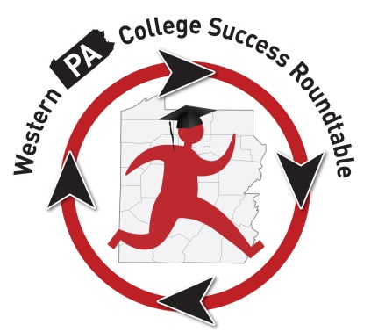
WPACSR “Retreat” Roundup
Membership Information:
This is the updated contact information for Roundtable Participants:
Attendance:
T
here were 28 folks in attendance at the July 22, 2016, Roundtable Retreat meeting at Pittsburgh Theological Seminary. Suzanne Angheloni, (USA Funds) Student Connections; Elaine Ashcom, Pitt Science and Tech 6-12; Rachael Banks, PSU Greater Allegheny; Jen Boehm, Rep. Dom Costa’s office; Amy Cribbs, AIU3; Alyssa Dobson, Slippery Rock University; Wendy Dunlap, PHEAA; Linda Ebel, Citizens School of Nursing; Eva Gelman, CollegeQuest; Stephanie Hendershot, Robert Morris University; Chalis Henderson, Univ. of Pittsburgh; Lorie Johnson-Osho, Grove City College; Shawn Jones, IUP; Heather Kindel, Saint Francis University; Patti McCarthy, IUP; Crystal McCray, California Univ. of PA (TRIO); Kim McCurdy, PHEAA; Loren Morgan, Central Catholic High School; Tashawn Nichols, Pittsburgh Public Schools; Melony Ohalek, Sallie Mae; Shari Payne, Waynesburg College; Samantha Rapp, Manchester Craftmen’s Guild; Peggy Schmeidecke, La Roche College; Debra Smallwood, Neighborhood Learning Alliance; Sean Thomas, CCAC North; Jynhae Tyler,

CCAC North; Michael White, Slippery Rock University; Dan Wray, PHEAA.

Meeting Items:

M
s. Heather Kindel, a PT instructor at Saint Francis University, presented this professional development assessment to the group. Participants were asked to discover which color represented them best, and we broke into like-colored groups to discuss how we see the world and what works best for us in terms of communication and interacting with others. Then we broke into mixed-color groups and tried to come up with some initiatives that the Roundtable might be able to institute over the coming year. Suggestions included a bus tour, a resource fair at the College Success Forum, an assembly program to survey students about their needs and then sharing resources with counselors, and a 1-day college workshop for parents and students. After discussion we determined we would be able to incorporate the resource fair at the CSF, and if anyone wants to take the reins and move forward with the other initiatives, we could try, but would need buy-in from institutions and potential partners as there would be costs surrounding those initiatives.

T
hank you so much to Heather for providing her expertise. Heather drove from Loretto, PA, to provide our training. If you have any further questions or would like to reach out to Heather, you can email her at hkindel@francis.edu.
Note from Heather: “Hi, I wanted to take a minute to thank each of you so much for attending the True Colors workshop on Friday morning. I really enjoyed meeting each of you. I’ve attached the poem I read at the end for your enjoyment. Thanks, Heather”
LinkedIn: Following lunch, Michael White from SRU provided an overview of LinkedIn for the group. After a survey of the members in attendance, it was determined that most of us have an account although the level of usage probably varies. He recommended setting up a group page. We will pre-approve those members who are on the distribution list for the Roundtable and invite everyone. Then we will be able to communicate as a group, share information, etc.
T
his also led to a discussion of our website, which although has been in existence for a couple years, we have found that there isn’t much traffic. It has been difficult to get things updated, etc. Dan Wray has been appointed as part of PASFAA’s technology committee to be the point person to get the site updated, so going forward, we should be able to make some improvements to the site. His first order of business is to get a user-friendly link. We will take down the information for the 15-16 academic year and start building again from there. If you haven’t been out there, the website is located at http://www.pasfaa.org/docs/outreach/wpcsr.html Currently, we provide a directory of current member contacts, Roundup notes, important dates to remember, and resources. We may consider putting together an official technology committee and utilizing other social media, etc. in the future. I’m sure we will be having further discussions about technology at upcoming meetings.
CS101: Kathryn Bethea, who had previously been the chair of the CS101 committee has resigned and is moving to Boston. Therefore, the CS101 committee will be meeting to determine how these efforts will continue in the future. If you are not familiar, CS101 provides programming to at-risk students from PPS and the surrounding areas around college access and success, as well as a college fair each May. Peggy Schmiedecke, who is a member of the committee, mentioned there may be things that our group can do to assist CS101 to ensure the programming continues. Peggy will attend their meeting in late August and report back to the group at the September Roundtable meeting as to how we might be able to help. More to come.
Grants in Support of Initiatives: As we mentioned, several ideas for programming that our group could provide to students came up during the True Colors activity. Michael White suggested that we may want to partner with a non-profit institution and consider doing some grant writing as a possible way to get funding for some of these initiatives. There was a call for committee members and so far the committee will consist of Shari Payne, Crystal McCray, Peggy Schmiedecke, Michael White, and Meloney Ohalek. If you would like to join the committee, please let me know asap at kmccurdy@pheaa.org, and I will get everyone connected via email.

Following the meeting, Jen Boehm from Representative Costa’s Office sent me the following document which includes educational grants that might be of interest. I haven’t looked at the listing yet and it is from a prior year, but this might be a good starting point and resource. Thanks, Jen!
Transition Committee: The transition committee has been around for a few years. Last year, the Service Project actually came out of this committee. The group has been re-formed for 2016-17 and will work toward creating some deliverables for our group centered around how we can utilize the resources within the Roundtable to ease transition for students from high school to college. So far, committee members include Michael White, Alyssa Dobson, Shawn Jones, Elaine Ashcom, Jynhae Tyler, Chalis Henderson, Sam Rapp, and Tashawn Nichols. If you would like to join this committee, please let me know asap and I will get you connected with this group as well. Again, please email me at kmccurdy@pheaa.org.
Adult Learners Committee: Linda Ebel asked if our group had ever done any programming or events centered on adult learners. Although we have not focused on this group, this is of course a large population of students depending on the institution and/or geographic location as business and industry changes and folks go back to school for retraining. We decided to form an Adult Learners Committee to meet and discuss initiatives (and deliverables) that could benefit adult students. Committee members include Linda Ebel, Wendy Dunlap, and Stephanie Hendershot. Let me know if you’d like to join this committee (kmccurdy@pheaa.org) and I can get you connected to the group.
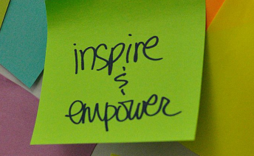
Future Service Projects: Be thinking about how our group can give back next year. As you recall, last year we collected items, gift cards, and cash to assist high school students with their dorm and school supplies as they head to college this fall. We might consider something similar or a totally different project. Bring your ideas to the upcoming Roundtable meetings or let me know if you have specific thoughts for consideration.

Early FAFSA/SAT Concordance: We had a bit of discussion around the Early FAFSA process. We think there are still families that don’t know about the changes on filing the FAFSA for 2017-18 starting in October or that they will use their 2015 tax information to complete the application. Please make sure your families are aware. PHEAA has posters and resources we can provide to help get the word out.
There was also discussion about the SAT and how Net Price Calculators might be updated and when to reflect the changes and how institutional money is awarded. We might consider inviting the College Board to an upcoming meeting to provide the latest and greatest. Let me know if you’d be interested in that.
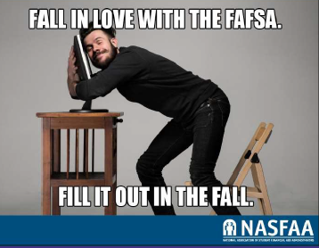

College Success Forum: RMU has been our host for the CSF for the past 4 years; however, we may have to consider looking for a different location based on building projects on campus. Stephanie Hendershot is working to confirm whether we can definitely have the event at RMU in February or if we need to find an alternative location. Several folks mentioned considerations including IUP, Manchester Craftsmen’s Guild, and PTS. Stephanie will find out for certain by mid-August and then we will begin making our plans accordingly. More to come on this. The CSF will be held on February 7, 2017.

PHEAA:

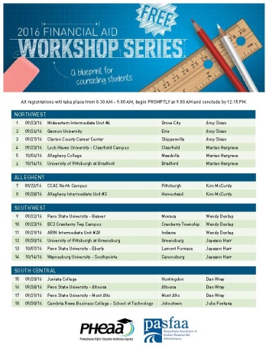
Don’t forget to save the date for our counselor workshops coming this fall. Click on the picture to see a complete listing of dates and locations.

Future Meetings:
-Tuesday, September 13, 2016, 10 a.m. – noon; Robert Morris University, Moon Township, PA.
-Tuesday, November 8, 2016, 10 a.m. – noon; AIU3, Homestead, PA
-Tuesday, January 10, 2017, 10 a.m. – noon; Location TBD
-Tuesday, February 7, 2017 – College Success Forum, 9 a.m. – 3 p.m.; Location to be confirmed soon
-Tuesday, March 14, 2017; 10 a.m. – noon; Location TBD
-Tuesday, May 16, 2017; 10 a.m. – noon; Location TBD

Make a Note: The NACAC College Fair in Pittsburgh will be held February 9 - 10, 2017.

Thanks again to PTS and Cheryl DePaolis for hosting our Retreat and for the wonderful lunch you provided! We appreciate your hospitality and couldn’t do what we do without you!

