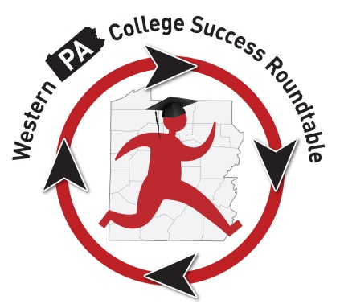
The “Roundtable” Roundup
Membership Information:
This is the updated contact information for Roundtable Participants:
Attendance:
T
here were 29 folks in attendance at the May 17, 2016, meeting. Ben Brudnock, Wells Fargo Bank; Jen Boehm, Rep. Dom Costa’s office; Jen Burns, Chatham University; Megan Colt, Chartiers Valley High School; Wendy Dunlap, PHEAA; Denise Fisher, Pittsburgh Technical Institute; Julie Fontana, PHEAA; Erin Grimm, AIU3; Marian Hargrave, PHEAA; Jayeann Harr, PHEAA; Anna Harrison (speaker), Duquesne University; Stephanie Hendershot, Robert Morris University; Jordan Knab (speaker), D.R.E.A.M. Partnership; Sherri Landis (speaker) D.R.E.A.M. Partnership; Sarah Loomis, Pittsburgh Technical Institute; Rachel Maurer, Junior Achievement; Patti McCarthy, IUP; Kim McCurdy, PHEAA; Loren Morgan, Central Catholic High School; Melony Ohalek, Sallie Mae; Megan Oleska, Youthworks Americorps member; Patty Peterson, PNC Bank; Karla Romero, Slippery Rock University; Peggy Schmeidecke, La Roche College; Doug Sermanera, Pittsburgh Technical Institute; Debra Smallwood, Neighborhood Learning Alliance; Heather Stevens, Youthworks; Sarah Vogel, OVR; Michael White, Slippery Rock University.

Old Business:
Legislative: We had been watching the following bills this year:
HB328 – Require Personal Finance Course as Graduation Requirement

SB111 – Pathways to College Act

SB760 – PA Dream Act

These bills were all in committee this year and no movement was reported. As the state legislature is in budget negotiations, we would not anticipate any movement on these until next fall. We may want to think about an advocacy campaign centered on legislation.

Service Project Update: We have collected the following items over the past several months for our service project – which was to bring school supplies and dorm materials to help students transition to college. Items collected included notebooks, pens, pencils, sheets, towels, laundry baskets, cleaning items, personal care items, gift cards, and cash. Debra Smallwood from NLA has identified several students to whom she will distribute the items closer to the start of the fall semester. She will provide a report back to us at the first Roundtable meeting of the new year next September.

New Business:
Speakers:
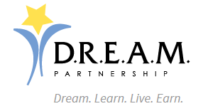
Our first speaker was Sherri Landis, Executive Director, and Jordan Knab, Business Consultant for the D.R.E.A.M. Partnership. The mission of the D.R.E.A.M. Partnership is to develop a selection of postsecondary educational opportunities for students with intellectual disabilities in PA that includes independent and supported dormitory options. They spoke about a few of the successful program that have started in PA and are interested in creating other partnerships. I will pass along the slide deck once it is shared with me. If you have any questions, please contact Sherri Landis at slandis@dreampartnership.org.
Our second speaker was Anna Harrison, Assistant Director of Internation Admissions at Duquesne University. She spoke about advising ESL students for admission to college and talked about the differences between refugee/asylee students versus someone who is coming from another country to attend work or school. She also spoke about the TOEFL and how every university is different so really advising the students to speak to the admission office at each school they are interested in applying. I will pass along the slide deck once it is shared with me. If you have any questions, please contact Anna at harriso530@duq.edu.
Summer Retreat: Our retreat is scheduled for Friday, July 22, 2016, from 10 a.m. – 2 p.m. at Pittsburgh Theological Seminary. We had previously discussed meeting this summer to consider where our group has come from and perhaps how we want to proceed moving forward in the years to come. Just based on some of the conversations I’ve had with members, we might want to consider various committees moving forward (transition and technology) or special projects/events to capitalize on the partnerships and collaborations we have within our group. Send me your thoughts and ideas and we will put together an agenda.
Other Business and Updates to the Group:
PA College and Career Consortium: From the First Lady’s Reach Higher campaign, a group has been formed under the direction of Patience Lehrman at Temple University to collaborate on what is being done around college access and success throughout Pennsylvania and then collaborate with other states on a national level. They are interested in representation from the Western PA College Success Roundtable, and while I am happy to be the liaison from our group to the larger group, there are opportunities for you to participate and represent what we’re doing in the west.
There will be a national meeting in Colorado on June 14-16. If you are interested in attending, let me know and I can get you connected to Patience and provide you with more information. This trip would be at you or your organization’s expense. There is also going to be a meeting in Baltimore this fall, and I will provide more details to the group as I receive them.

PACAC Camp College:
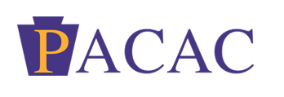Loren Morgan shared that there will again be a Camp College event at Albright College on July 26-28. They are recruiting mentors as well as student participants. Please visit http://www.pacac.org/index.php?option=com_content&view=article&id=102:camp-college&catid=20:site-content&Itemid=157 if you’re interested in learning more information. Loren also mentioned that PACAC is planning to hold this event in western PA in 2017, so if you can’t participate this year, there could be upcoming opportunities for next summer. Stay tuned!

Wells Fargo: Ben Brudnock said that Wells Fargo is scheduling student sessions, to be held during the daytime at schools, that help students understand upcoming deadlines, cancelling schools they had applied and been accepted to, documents they might need, and general transition information that students need as they graduate from high school and look toward college in the fall. If you’re interested in speaking to Ben about possible speaker opportunities at your school, please email him at benjamin.brudnock@wellsfargo.com.
Sallie Mae: At one of our prior meetings, Melony Ohalek let us know about their Make College Happen Scholarship opportunities. Students sent in submissions, and we were asked to vote. $100,000 was raised by Sallie Mae and its employees and was awarded to 4 deserving students. Check out the award ceremony video here. https://www.youtube.com/channel/UCI7MZRTE_K90K3Uj1TJQC7w

Central PA Education Collaborative (CPEC): Our group has been invited to attend the June 10 meeting of CPEC, which is a group similar to ours in the central part of PA. They have been in existence for 2 years and would like to chat about the things we’ve done and how we might be able to work together in the future. I will be attending that meeting. If you’re interested in attending, please email me at kmccurdy@pheaa.org and we can coordinate our attendance.

PHEAA:

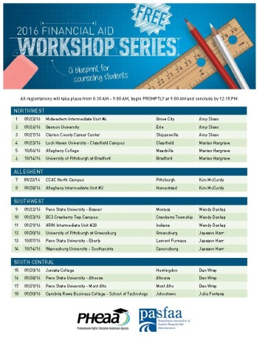
Don’t forget to save the date for our counselor workshops coming this fall. Click on the picture to see a complete listing of dates and locations.

Future Meetings:
- Friday, July 22, 2016: Roundtable Retreat; 10 a.m. – 2 p.m. at Pittsburgh Theological Seminary in Pittsburgh.
- Tuesday, September 13, 2016: 10 a.m. – noon; Robert Morris University, Moon Township, PA.

Special thanks to Pittsburgh Technical Institute and Sarah Loomis for hosting our Roundtable meeting. Thank you for the refreshments and your hospitality! On behalf of the Roundtable group, we really appreciate you! Looking forward to seeing you again soon!

