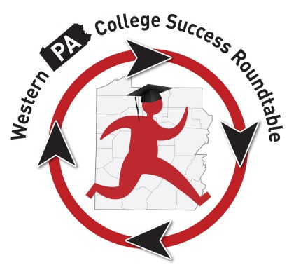Membership Information:
The “Roundtable” Roundup
This is the updated contact information for Roundtable Participants:
Attendance:
T
here were 15 folks in attendance at the March 8, 2016, meeting. Sean Barrett, Rosedale Technical College, Amy Cribbs, AIU3; Sophia Duck, Youthworks; Wendy Dunlap, PHEAA; Stephanie Hendershot, Robert Morris University; Tammy Manko (speaker), IUP; Patti McCarthy, IUP; Kim McCurdy, PHEAA; Melony Ohalek, Sallie Mae; Sean Riffle, JobCorps; Mike Rose, CCAC South; Michael Scheidlen, JobCorps; Peggy Schmeidecke, La Roche College; Robert Tallerico, PSU Fayette; Michael White, Slippery Rock University.

Old Business:
Legislative Update:

There is still no resolution to the state budget from 2015-16; therefore, most of the bills we have been following have had no action and remain in committees.

In addition to the bills we have been following, there is a bill in the US Senate to note. Introduced by Senator Casey, this bill would aim to eliminate the drug question from the FAFSA. The question currently asks students who have received financial aid if they have been convicted of a drug felony while receiving funds. PASFAA supports this bill as the question is often a point of confusion for students and can impact whether they continue to receive funding. Often this funding is a means to get out of whatever situation they might be trying to overcome. We will have more on this at a later date.
Robert Tallerico mentioned that the budget is still affecting State-Related Institutions as they have not received any of their state funding at this point. They have been operating without this payment, and it has led them to consider over 1100 layoffs in the upcoming year. PSU is looking at increasing tuition next year as well. Other schools are considering this as well. This is a good reminder to continue contacting your local legislators and ask them to act on getting this budget passed ASAP. The lack of a budget is continuing to impact our students in many ways.

CSF Wrap-Up: The 4th Annual CSF was held on Feb. 4, 2016, at Robert Morris University. There were 132 attendees at the Forum (which included one parent participant). A survey was sent to all attendees and there were 64 responses collected. Most of the comments were positive, and the summary report can be found here.
There were several suggestions for improvements and topics to be provided as training next year. Consideration will be made to incorporate some of this feedback when planning resumes in the fall for next year’s event.
Service Project Update: As you know, we are still collecting items for high school students as they transition to college next year. Items may be brought to the next Roundtable meeting on May 17, or see contact information on the flyer that is attached and arrangements can be made to have the donations picked up. To date, we have collected a back pack, shower caddy, stackable bins, laundry baskets, laundry soap, notebooks, highlighters, pens, pencils, binders, toiletries, umbrellas, step stools, gift cards, and cash. Debra Smallwood at NLA will begin to identify approximately 20 students to assist, and we will keep you updated.

New Business:
Speaker: Our speaker at the meeting was Dr. Tammy Manko from IUP. Dr. Manko is the Director of IUP’s Career and Professional Development Center, and she spoke on “Career-Ready Students.”
There was a lot of good information and lots of conversation around this topic. Here is the link to the TED Talk she mentioned, “Start with Why” by Simon Sinek. (She also referenced his book by the same name).
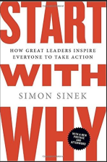
https://www.youtube.com/watch?v=qp0HIF3SfI4
Dr. Manko will be providing her slides and as soon as I receive them, I will send them out to the group. In the meantime, if you have any questions, you may reach her at Tammy.Manko@iup.edu.
Summer Retreat: We discussed perhaps meeting over the summer, but instead of a structured meeting, having a retreat to discuss what we’ve done in the past and where we want to keep moving in the future. It was decided that late-July might be a good time to meet. Further information will be provided. We are looking at Rosedale Technical College as a potential host site. They have a room for us to meet and have a cafeteria on-site where we could break for lunch. We are also thinking of sending a general survey out to the membership first so we can prepare small-group discussions and be as productive as possible. Your input is appreciated.
Other Business and Updates to the Group:
AIU3: Amy Cribbs is working with all school districts in Allegheny County on the Chapter 339 program, outlining how schools can get students career ready. They need panelists for their event on March 31 from 9 a.m. – 10:30 a.m. They need the following:
- A postsecondary rep who is champion in the area, who responds positively to working with schools.
- A representative from a four-year college/university
- A representative from a short-term diploma/certification program(s).
- A representative from the military and/or an apprenticeship program.
- A representative of associate degree programs (community college or some universities).
- An employer who offers extensive on-the-job training.
If you would like to volunteer to be a panelist, please reach out to Amy at amy.cribbs@aiu3.net.
Upcoming Events:
- Thursday, April 14, 2016: The Missing Semester Student Financial Literacy Panel @ AIU3. 9 a.m. – noon for teachers; Student Panel at 11 a.m. More information to come.
- Friday, April 22, 2016: PACAC’s Western PA College Counseling Workshop @ Chatham University. 9 a.m. – 1 p.m. (registration will be available soon).
- Monday, May 9 – Tuesday, May 10, 2016: PACAC’s College Access Forum and Legislative Action Day in Harrisburg (Free to attend; register at PACAC.org).

- Thursday, May 12, 2016: CS101 College Fair at PSU Greater Allegheny. 9 a.m. – 1 p.m. (contact Kathryn Bethea for more information at kabethea@gmail.com).
- Saturday, May 14, 2016: Tech Savvy Girl event at La Roche College for girls in grades 6 - 9. 7:30 a.m. – 4 p.m. See attached flyer for cost and registration information.
Future Meetings:
- Tuesday, May 17, 2016; 10 a.m. – noon; Pittsburgh Technical Institute, Oakdale, PA
- Late July – Roundtable Retreat – More information to follow
- Tuesday, September 13, 2016; 10 a.m. – noon; Robert Morris University, Moon Township, PA.

Special thanks to IUP and Patti McCarthy for hosting our Roundtable meeting. Thank you for the refreshments and your hospitality! On behalf of the Roundtable group, we really appreciate you! Looking forward to seeing you again soon!

